Computer Science

A level Computer science is split into two complementary sections, programming and theory. On the programming side of the course, students can learn a programming language. You will cover the fundamentals of programming, data structures, algorithms, and object-orientated programme design.
For the following two tasks you are required to develop algorithms and code your algorithms. If you have not done any coding, then we MUST see your algorithms. Your algorithms are the most important part of this task. You can use any programming language.
These tasks are not about getting it correct (if you do then fantastic), it is about developing your thinking and allowing us to get an idea of the type of research you have done.
For the following two tasks you are required to develop algorithms and code your algorithms. If you have not done any coding, then we MUST see your algorithms. Your algorithms are the most important part of this task. You can use any programming language. These tasks are not about getting it correct (if you do then fantastic), it is about developing your thinking and allowing us to get an idea of the type of research you have done.

For the following scenario analyse the detailed requirements for each situation and, using suitable algorithms, design a solution to be coded in a suitable high-level programming language. Show the iterative development of the individual solutions. Each of the tasks may be solved as a separate system.

Stock control.
Products are identified by a GTIN-8 (Global Trade Item Number), this is often represented using a barcode.

In this barcode, the GTIN-8 is 1324 5627.

The GTIN-8 uses a seven digit code plus a check digit for validation. The eighth digit of a GTIN-8, the check digit, is calculated as follows:
For example, the seven digits 1324562:

Repeating the process of multiplying by 3 then 1 will give a sum that is a multiple of 10 that can be used to check the validity of the GTIN-8 product code.

For example, the eight digits 13245627:
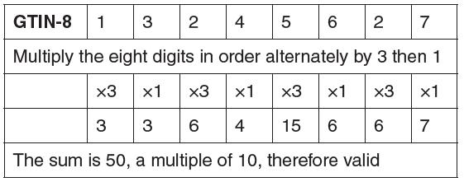

Task
Analyse the requirements for this system and design an algorithm to:
- Calculate the GTIN-8 product code from a seven digit number
- Check the validity of an eight digit GTIN-8 code
When you have designed your algorithm, attempt to code the algorithm.

Task
Create a suitable text file to use with a high-level programming language containing a list of product details, including a GTIN-8 product code, a product description and price.
The program should allow a user to enter GTIN-8 codes for a list of products they wish to purchase and the quantity required of each product. The program should search the stock file to produce a list of products with their descriptions, prices, cost for each of the quantity selected and the total cost for all of the products. The program should also identify products not found.
