Geography

Reading List

At A Level Geography it is expected that you can demonstrate to the examiners that you have been partaking in wider reading.

Below is a list of books/journals and websites you could use over the next two years and beyond in university.

OUP - Edexcel GCE Geography Y1 A Level Student Book and eBook (Oxford University Press) | https://global.oup.com/education/product/9780198366454/?region=uk
Pearson - Edexcel GCE Geography Y1 A Level Student Book (Pearson) | http://www.pearsonschoolsandfecolleges.co.uk/Secondary/Geography/16plus/EdexcelGeographyALevel2016/ISBN/Other/Student-Books/Edexcel%20AS%20Year%201%20Geography%20Student%20Book%201%20and%20ActiveBook.aspx
Hodder - Edexcel GCE Geography Y1 A Level Student Book (Hodder Education) | https://www.hoddereducation.co.uk/Product?Product=9781471856549
This is a list of some books you might want to consider
Geography: An Integrated Approach Fourth Edition | https://global.oup.com/education/product/9781408504079/?region=international

Some good Geography magazines are:
Geography Review, Go to: http://www.philipallan.co.uk/geographyreview/index.htm
Geographical, Go to: http://www.geographical.co.uk/Home/index.html

Tectonic Processes and Hazards
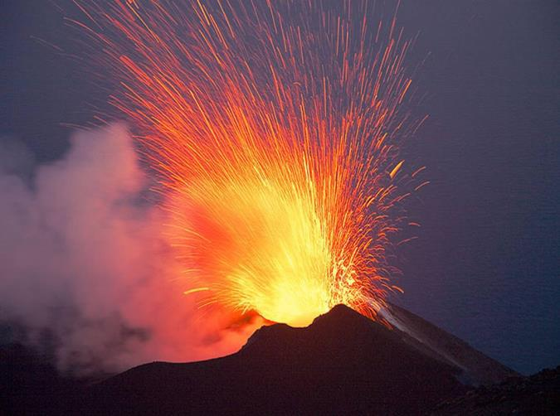

In this topic you will be understand why some locations are more at risk from tectonic hazards than others, why some tectonic hazards develop into disasters and how successful the management of tectonic hazards is.
Task
In April 2015 a 7.8 magnitude earthquake hit Nepal, this earthquake turned into a natural disaster for Nepal. Using research, answer the following:
- What turns a natural hazard into a natural disaster?
- Why was there an earthquake in Nepal?
- What were the primary and secondary effects of the earthquake?
- What were the responses to the earthquake?
- Why did the Nepal earthquake develop into a disaster?
- ‘The Nepal earthquake was successfully managed’ To what extent do you agree with this statement?
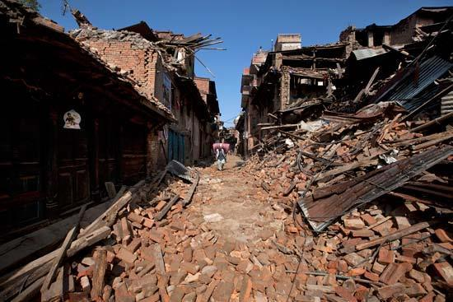

Globalisation
In the last 30 years, globalisation has taken a real front seat in the concepts taught at A level geography. Changes in economy are at the forefront however changes in the environment, culture, demographics and politics of the world are also important and impact on areas at a range of scales.
Key past influences
- Since the discovery of the Americas, world trade and economy began to take shape.
- The colonialism of certain countries enabled the British Empire to control ¼ of the world bringing along British culture.
- The founding of the United Nations after the first world war allowed countries to work together easily.
Continued influences and evolution of globalisation
- Transnational Corporations (TNC): These are top firms with HQs usually in HICs however operate all over the world and are globally recognised (Coca Cola, Disney, Apple).
- Internet and IT: These have allowed design and manufacturing to be faster and easier. Jobs that typically humans would have done are now done online by less people-Allowing many high tech industries to be “footloose” and not reliant on being near by a resource or labour force.
- Transport: Now quicker, more efficient and low cost. The arrival of the 747 in the 1960s has revolutionised trade and movement of people.
- Growth of markets: Increase in urban living means more demand for trade, services and products.
Global groupings
- Trade blocs: To trade easily between countries, certain agreements have been created. Examples are EU, NAFTA, CARICOM
- Economic groupings: Countries are grouped together based on wealth and power. Example are LICs/HICs (LDC or HDCs), NICs, OPEC and OECD.

Task
What do the acronyms above stand for?

TNCs and Trade aims
- They tend to operate where labour is cheap and regulations are lacking
- To gain government grants from countries that are attracting new business
- They operate inside local trade barriers and avoid tariffs
- They like to be near markets
Positives to TNCs
- Raising living standards – TNCs invest in the economies of many NICs and LICs
- Transfer of technology – south Korean firms e.g. Samsung have learned to design products for foreign markets
- Political stability – investment by TNCs has contributed to economic growth and political stability e.g. China
- Raising environmental awareness – due to large corporate image TNCs do respond to criticism e.g. Starbucks have their sustainability campaign
Negatives to TNCs
- Tax avoidance – many avoid paying full taxed in countries they operate in through concessions, e.g. Starbucks and Amazon
- Limited linkages – FDI does not always help developing nations economies
- Growing global wealth divide – selective investment in certain global areas is creating a widening divide e.g. Southeast Asia vs. sub-Saharan Africa
- Environmental disaster and destruction – example of Bhopal, India disaster in 1984

Task
Create an annotated photo of either your family car or your living room with the various places where the parts/ features were manufactured.

Task
Choose an example of a TNC and create a timeline of events since their foundation as a company. What have been the benefits that the company has brought to the countries involved. Examples could be Nike, Mattel, Disney or Tesco.

