Plumbing
In preparation for your plumbing course research the topics covered in the questions and then attempt the questions.

- What is the abbreviation for the regulation that ensures that electrical work equipment is suitable, well maintained, and used correctly?
  - PUWER.
  - POWER.
  - POWDER.
  - PURGE.

- Which organisation provides information and advice about work-related health, safety and illness?
  - Health and Social Executive.
  - Health and Safety Executive.
  - Health and Safety Expert.
  - Health and Social Expert.

- Who is responsible for providing PPE when working on site?
  - Employer.
  - Main contractor.
  - Site foreman.
  - Client.

- What is the correct cable colour coding used for 110 V construction site equipment?
  - Red.
  - Yellow.
  - Blue.
  - White.

- What is the maximum recommended voltage for drills on site when battery powered tools are not available?
  - 414 volts.
  - 230 volts.
  - 315 volts.
  - 110 volts.

- When should ladders be considered for use on site?
  - Access or light work of short duration and if it is safe.
  - Heavy work for long durations and if it is safe.
  - If they are long enough to reach the access point.
  - If they are erected at an angle 1:6.

- Trenches should be excavated to what maximum depth before supports are required?
  - 1.2 m
  - 1.6 m
  - 2.0 m
  - 2.4 m

- What power tool is shown in the image?
  - Crimping tool.
  - Pipe cutter.
  - Reciprocating saw.
  - Pipe threader.

- Which size masonry drill bit would be most suitable when fixing a number of 15 mm plastic clips to a brick wall using red plastic plugs?
  - 6 mm
  - 9 mm
  - 12 mm
  - 15 mm
- Why would we use a work programme on a plumbing contract?
  - To monitor the progress of the work.
  - To show where the components are to be fitted.
  - To list all materials required for the contract.
  - To record all money spent on the contract.

- What copper tube grade would be most suitable for installing underground cold water services?
  - R200 (reinforced).
  - R220 (annealed).
  - R250 (half hard).
  - R290 (hard).

- What are ripples most commonly caused by when bending copper tube on a bending machine?
  - Excessive pressure from the roller.
  - Inadequate pressure from the roller.
  - Using new equipment.
  - Using old equipment.

- What does R1 and R2 equal when R1 is x4 the diameter of a 15 mm tube and the tubes are spaced 80 mm apart?
a. R1 = 60 mm, R2 = 140 mm
b. R1 = 60 mm, R2 = 150 mm
c. R1 = 65 mm, R2 = 130 mm
d. R1 = 65 mm, R2 = 160 mm

- What is the ductility of a metal?
  - Its ability to be stretched without breaking.
  - Its hardness to resist scratching.
  - Its ability to transfer heat.
  - Its ability to resist corrosion.

- What is an example of a thermosetting plastic?
  - Polyester.
  - ABS.
  - Polypropylene.
  - Polyethylene.

- Which pair of metals will be effected by electrolytic corrosion the most when in the presence of moisture?
  - Tin and lead.
  - Iron and zinc.
  - Copper and iron.
  - Copper and aluminium.

- What type of material allows the free movement of electrons?
  - Good conductor.
  - Good insulator.
  - Good resistor.
  - Good transformer.

- What size over current protection device is most suitable to protect a circuit that has a 9kW electric shower installed on a 230volt supply?
  - 16 amps.
  - 32 amps.
  - 40 amps.
  - 50 amps.

- What water source is best for providing water of a good quality?
  - Deep well.
  - Shallow well.
  - River.
  - Canal.

- What pipe brings water from the water main at the property boundary up to the stop tap in the property?
  - Supply pipe.
  - Communication pipe.
  - Service pipe.
  - Distribution pipe.

- Which cold water system has the following advantages?
Reserve water supply Reduced risk of water hammer Less risk of back flow
Showers may be supplied at equal pressure

  - Indirect system.
  - Direct system.
  - High pressure system.
  - Gravity system.

- What sequence of treatment does water go through before it is classed as wholesome?
  - Sedimentation, filtration, sterilisation.
  - Filtration, sterilisation, sedimentation.
  - Sterilisation, sedimentation, filtration.
  - Sedimentation, sterilisation, filtration.

- Which document contains information about the correct accommodation of pipes in walls and is classed as a statutory document?
  - Manufacturer’s instructions.
  - BS EN 806.
c. BS 6700.
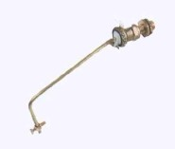
d. The Water supply Regulations 1999.
- What type of FOV is shown in the image?
  - BS 1212 Part 1
  - BS 1212 Part 2
  - BS 1212 Part 3
  - BS 1212 part 4

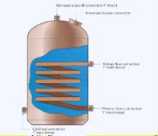
- What type of hot water cylinder is shown in the image?
  - An indirect single feed cylinder.
  - A direct double feed cylinder.
  - A direct twin coil cylinder.
  - An indirect single coil cylinder.

- What are the most important factors to be considered when selecting a type of hot water installation?
  - Occupancy, distance to outlets, mains pressure available.
  - Building materials, floor height, size of pipework.
  - Local labour availability, floor plan of building, occupancy.
  - Owner preference, floor height, weight of cistern.

- To create a reasonable shower pressure the minimum distance from the bottom of the supply cistern to the shower head would be?
  - 0.5 m
  - 1.0 m
  - 1.5 m
  - 2.0 m

- Hot water should be supplied through a thermostatic mixing valve at what outlet temperature (degrees C)?
  - 34 ⁰C
  - 43 ⁰C
  - 50 ⁰C
  - 65 ⁰C

- What is checked during commissioning at the appliance to ensure pipe sizes are correct on a hot water system?
  - Pressure and flow rate.
  - Pressure and expansion rate.
  - Flow rate and discharge rate.
  - Temperature and turbulence.

- What is the benefit of a system that has secondary circulation?
  - It prevents water wastage.
  - It reduces the installation costs.
  - It increases the pressure at the appliance.
  - Smaller diameter pipes can be used.

- Which of the following fuels is classed as being a renewable fuel source?
  - Biomass.
  - LPG.
  - Natural gas.
  - Coal.
- What is the maximum notch depth if a joist is 150mm deep?
  - 22.75 mm
  - 20.75 mm
  - 15.75 mm
  - 18.75 mm

- Which component on a sealed central heating system accommodates the expansion of water when it is heated?
  - Expansion relief valve.
  - Expansion vessel.
  - Pressure gauge.
  - Cistern.

- What is the correct source of information to ensure the correct radiator is installed in the correct room of a building?
  - Radiator schedule.
  - Specification drawing.
  - Manufactures installation guide.
  - Bill of Quantities.

- Why are radiators best hung at 150 mm off the floor?
  - To allow air circulation around the radiator.
  - Prevent radiator valves resting on the floor.
  - So skirting boards can be painted.
  - To allow for cleaning underneath.

- What is the consequence if rainwater collected in guttering at the eaves was allowed to discharge onto the soil around the building?
  - Soil erosion.
  - Soil compaction.
  - Soakaway failure.
  - Improved soil conditions.

- What are the most important things to be taken into account when sizing and choosing the guttering system on a property?
  - Rainfall intensity, roof area, and gutter fall.
  - Material type, height, drainage system type.
  - Environmental factors, weight, labour availability.
  - Drainage connection, rainfall direction, durability.

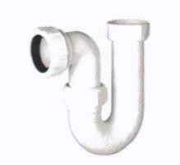
- What type of trap is shown in the image?
  - Bottle trap.
  - Resealing trap.
  - Tubular P trap.
  - Waterless trap.

- What appliance would be most likely to use a dual flush valve in its operation?
  - WC suite.
  - Bath.
  - Wash basin.
  - Urinals.

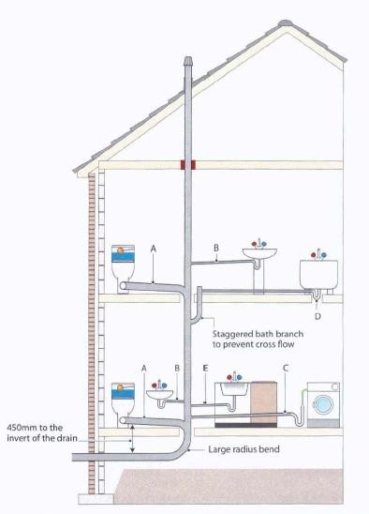
- What type of sanitary pipework system is shown in the image?

  - Stub stack.
  - Primary ventilated stack system.
  - Ventilated discharge branch system.
  - Secondary ventilated stack system.

- What is the most appropriate reason why oil and LPG fuel systems are commonly used in rural areas?
  - Bulk storage of the fuel is possible.
  - These fuels are the only two alternatives.
  - The cost of the fuel is always lower.
  - These fuels are more environmentally friendly.

- How do we ensure the correct operation of a sub stack when installing?
  - By adhering to specified measurements.
  - Always install antisiphonic traps on all appliances.
  - Increasing the pipe diameter of the wc connection.
  - Including a short radius bend at the base of the stack.

- How should the following sequence of activities be re arranged to ensure the successful completion of a repair to a soil stack?
- Test repair.
- Notify customer.
- Carry out repair.
- Wear correct PPE
- Decommission appliance.

a 2, 4, 5, 3, 1.
b. 5, 4, 3, 2, 1.
c. 1, 3, 2, 5, 4.
d. 3, 2, 4, 1, 5.

The below scenario should be used to answer questions 44 and 45

Upstairs radiators in a 30 year old heating system in a dwelling get hot in the summer when the hot water cylinder is being heated from the central heating boiler.

- What is the most likely reason for why this is occurring?
  - Water from the expansion vessel is circulating around the pipework.
  - The time clock is switching on the pump in reverse due to incorrect wiring.
  - The radiators are being heated by means gravity of circulation.
  - The ambient air temperature is making the radiators hot.

- The customer has requested to be able to control the hot water circuit as well as upstairs and downstairs heating independently and has been given the following advice.
‘To install a 3x2 port heating system’

What statement best reflects the advice given:
  - The advice is correct, meets legislation and customer needs.
  - The advice is incorrect meets legislation but not the customer needs.
  - The advice is correct does not meet legislation or customer needs.
  - The advice is incorrect does not meet legislation or meets customer needs.

- A ground floor flat in a 5 storey block is having problems with foam and waste water appearing in the bath and WC which are connected to the soil stack. The inspection chamber is checked but there is no blockage.
What is the most likely reason why this is happening?
  - Incorrect type of traps used on appliances.
  - Waste pipes enter stack at the incorrect gradient.
  - Too many washing machines and dishwashers are connected to the stack.
  - Connection at the base of the stack is less than 750mm to invert level.

- Water is heated and stored at certain temperature range and blended at point of use’. Which of the below statements best supports this.
  - Water is heated and stored at 60-65 degrees to eliminate lime scale and prevent bacteria growth.
  - Water is heated and stored at 60-65 degrees to eliminate electrolysis and prolong the life of the storage cylinder.
  - Water is heated and stored at 50-55 degrees to eliminate lime scale and prevent bacteria growth.
  - Water is heated and stored at 65-70 degrees to eliminate copper sulphates and prevent bacteria growth.

- What reason best supports the below statement?
‘on a bath installation temperature blending valves are mandatory in new build properties’.

  - Due to part G of the building regulations and to prevent scalding and limit temperature to 48 degrees.
  - To allow the customer to have full control of the temperature of the bathing temperatures.
  - Due to part L of the building regulations and to prevent scalding and limit temperature to 43 degrees.
  - Limiting temperatures to conserve energy and increase energy rating of the property.

- 22 mm copper tube and fittings are to be installed across the full length of two long and one short wall of a 3m by 2m room. Smoke alarms cannot be turned off in the property. Elbow fittings will be used in the corners. All joints are to be made in position with minimal wall damage.

Which list of materials will be suitable for the installation?
  - 8 m of 22 mm copper tube, 2 x 22 mm push fit elbows.
  - 7 m of 22 mm copper tube, 2 x 22 mm compression elbows.
  - 8 m of 22 mm copper tube, 2 x 22 mm solder ring elbows.
  - 7 m of 22 mm copper tube, 2 x 22 mm push fit elbows.
- You are asked to look at 2 long horizontal heating pipes that pass through 4 walls. You see on either side of the wall broken plaster on the floor and plaster damage around the pipes. You have been told that the damaged plaster has been repaired and painted a number of times.
What is the most likely cause of the damage?
  - No plastic tape on the pipe to stop the plaster sticking
  - No paint applied to the pipe in the wall to allow the pipe to slide
  - The wrong type of plaster used and no pipe covers used
  - No sleeves on the pipe to allow movement of the pipe through the wall

- On a cold water installation the pipes are under the floor are close to a 22 mm hot water pipe. The customer is complaining that the cold water supply is warm and a considerable amount of water has to be run off before it goes cold. Following investigation, work needs to be carried out to rectify the problem.

Which statement best reflects the most cost effective solution?
  - Insulate the hot and cold water pipes to prevent heat transfer.
  - Increase the cold water pressure to run off water quicker.
  - Re-site the hot water pipe further away from cold pipe.
  - Re- route the cold water pipe away from the hot water pipe.

- A newly installed guttering system is over flowing at peak rainfall periods. The owner of the property called a plumber, who identified the current system had no blockages and was operating as designed.

Which statement best reflects the most cost effective solution?
  - Reduce the pitch of the roof to slow down the discharge.
  - Replace the full system with a high capacity type.
  - Increase the length of guttering to allow for excessive rainfall.
  - Increase the roof area to capture more rainfall at peak times.

- Using the diagram identify the type of central heating system this relates too and then define what would be the consequences when the system is in operation.
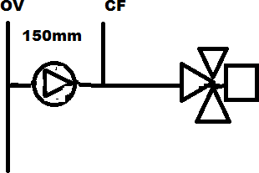
  - Open vented system under negative pressure which is drawing air into the system.
  - Open vented system under positive pressure which is drawing air into the system
  - Sealed system under negative pressure which is drawing air into the system
  - Sealed system under positive pressure which is drawing air into the system

- You are called in to investigate a wash basin waste that is blocked. What you find is a 32 mm waste pipe connected into the soil stack in the shaded area as highlighted on the drawing.
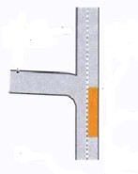
Which statement explains the situation?
  - Legislation allows connections in shaded area if pipe diameter is greater than 32 mm.
  - Legislation forbids any connections other than WC in the shaded area.
  - Legislation forbids any connections in the shaded area due to cross flow.
  - Legislation allows connections in the shaded area as long as they have cleaning access.

- Below are four pictures of heat emitters which could be connected to a central heating system.
Select the sequence of letters which correctly identifies them in the correct order as a skirting radiator, a convector radiator, a plinth heater and a column radiator.
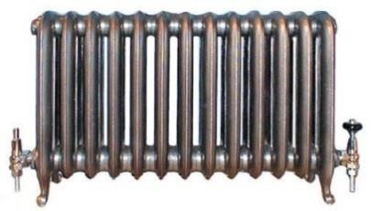
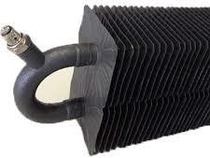

A B C D

  - A, B, C, D.
  - C, D ,A, B.
  - B, C, A, D.
  - A, B, D, C.

- We have two connections on a cold water storage cistern proving balanced hot and cold supplies to a shower block via a cistern and an indirect hot water cylinder.
- Cold feed to hot supply via an indirect hot water cylinder
- Cold feed direct to showers

What is the correct statement with regards to positioning of connections within the cistern?
- Cold feed supply connection direct to the showers must be higher than the supply to the hot water cylinder to prevent scalding.
- Cold feed supply connection to the hot water cylinder must be higher than the cold outlet direct to the showers to prevent scalding.
- Cold feed supply connection to the hot water cylinder must be from the bottom of the cistern to prevent scalding and scale build up.
- Open vent connection to the hot water cylinder must be from the bottom of the cistern to prevent scalding and scale build up.

- How much pressure should a rigid hot water pipework system with a maximum working pressure of 4 bar be tested to according to the water regulations?
  - 9 bar.
  - 8 bar.
  - 7 bar.
  - 6 bar.

- The incoming water flow rate to a property has been confirmed at 8 litres/ minute, what is the reading in litres/ second?
  - 0.08 litres/ second.
  - 0.1 litres/ second.
  - 0.13 litres/ second.
  - 0.15 litres/ second.

- Which document should be referred to for guidance on the commissioning requirements for a central heating boiler?
a. BS 6700: 2009.
- Manufacturer’s instructions.
- Water supply (Water Fittings) Regulations.
- Domestic Building Services Compliance Guide.

- A plumber is to undertake work in a school gymnasium, replacing rainwater pipes connected to roof outlets, which will require them working off a tower scaffold. The plumber has attended a training session on the potential dangers and precautions required during use of tower scaffold. The company they work for employs a person who has been trained in tower scaffold erection and is competent.

Which of the following best outlines the correct procedure to be followed?
  - Competent person erects tower scaffold/plumber inspect on a daily basis and make any notes/competent person inspect on a weekly basis.
  - Competent person erects tower scaffold/ plumber inspect on a weekly basis making notes and submits a report to their supervisor.
  - Plumber erects the tower scaffold the competent person inspects it the day after and says all is correct/ competent person inspects on a weekly basis.
  - Plumber erects the tower scaffold using supplied instructions/plumber inspects on a daily and weekly basis and submits report.

Mark scheme

Question |  | Key |  | Question |  | Key
1 |  | A |  | 31 |  | A
2 |  | B |  | 32 |  | D
3 |  | A |  | 33 |  | B
4 |  | B |  | 34 |  | A
5 |  | D |  | 35 |  | A
6 |  | A |  | 36 |  | A
7 |  | A |  | 37 |  | A
8 |  | A |  | 38 |  | C
9 |  | A |  | 39 |  | A
10 |  | A |  | 40 |  | B
11 |  | B |  | 41 |  | A
12 |  | B |  | 42 |  | A
13 |  | A |  | 43 |  | A
14 |  | A |  | 44 |  | C
15 |  | A |  | 45 |  | A
16 |  | D |  | 46 |  | D
17 |  | A |  | 47 |  | A
18 |  | C |  | 48 |  | A
19 |  | A |  | 49 |  | A
20 |  | C |  | 50 |  | D
21 |  | A |  | 51 |  | A
22 |  | A |  | 52 |  | A
23 |  | D |  | 53 |  | A
24 |  | B |  | 54 |  | C
25 |  | D |  | 55 |  | D
26 |  | A |  | 56 |  | A
27 |  | B |  | 57 |  | D
28 |  | B |  | 58 |  | C
29 |  | A |  | 59 |  | D
30 |  | A |  | 60 |  | A

