Sport

BTEC Sport Level 3 provides you with the skills required to study at a higher level whilst also developing the background knowledge that will be useful in the Sports Industry. Students who have studied this course in the past have followed a wide range of pathways including university, training schemes, and employment. Previous degree courses followed include; Sport and Exercise Science, Sport Management, Sports Coaching, Sport Development and Coaching, and Sports Nutrition.

Useful Resources
BTEC National Sport – Student Book 1 and Student Book 2. (2016 Specification)
Revise BTEC National Sport Units 1 and 2 (Revision Guide and Revision Workbook)

Internet
There are a huge variety of web sites that you can use to help you with your work. It is important to remember that in order to get the best marks possible you will need to show evidence that you have read around the subject and can show an ‘in depth’ understanding of the topic. Due to the nature of the internet, the web addresses are constantly changing.
Be careful, not everything on the internet is correct, use your common sense and only use the internet as a source in addition to your text books and resources given!
Work must be produced independently and be referenced properly. Plagiarism will severely affect your grades.
Some of the most common websites specific to the requirements of this course are detailed below;
British Olympic Association, http://www.olympics.org.uk/
Department of Culture, Media and Sport http://www.culture.gov.uk
Sports Coach UK, http://www.sportscoachuk.org.uk
Sport England, http://www.sportengland.org
Inner Body, http://innerbody.com
Peak Performance, http://www.pponline.co.uk
Psychology Lab, http://wwwgeocities.com/lazaridous/
Training Programmes/Principles, http://www.brianmac.demon.co.uk/
UK Sport, http://www.uksport.gov.uk
Sport Injury Journals, http://www.physsportsmed.com/
National Library of Medicine, www.ncbi.nlm.nih.gov/entrez/query.fcgi

Activity
Introduction
The human body is made up of many different systems that work together and allow us to take part in a huge variety of sport and exercise activities. An athlete can go from rest to all-out sprinting in a matter of seconds, whereas an endurance athlete can continue exercising for many hours at a time.
The skeletal and muscular systems work together to allow our bodies to perform a vast range of different movements. Our cardiovascular and respiratory systems act as a delivery service, working together to supply oxygen and nutrients to the body which in turn is used to produce energy for muscular contraction.
In order to appreciate how each of these systems function, you will study the structure of the skeletal, muscular, cardiovascular and respiratory systems. The human anatomy of these systems is very different but in terms of operation, each system is implicitly linked. Having an understanding of these body systems is imperative in the sport and active leisure industries in order to begin to appreciate how the body functions and how it copes with the many different stresses of exercise.
Scenario
University places are extremely hard to get onto now days. You have applied for a place on a sports coaching degree. You have been called for an interview for a place on the course you want so much. As part of the application you must demonstrate a knowledge & interest in sport and the influences on performance. You have been given the topic of the Skeletal system to research & must be prepared to present and discuss fully in a discussion with an interview panel at the university.
www.brianmac.com
http://innerbody.com

Task
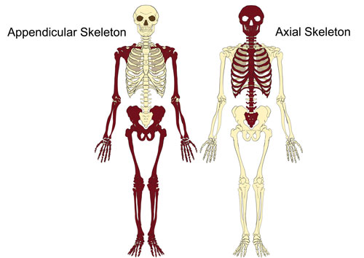
Using PowerPoint prepare slides for your discussion with your teacher:
- Find a blank picture of the AXIAL skeleton & label it
- Find a blank picture of the APPENDICULAR skeleton & label it
For each you will be required to describe:
- where it is located
- the bones that form that part of the skeleton
- what that skeleton’s function & role is
- what movement it allows
Do not forget to reference your work and pictures

Task
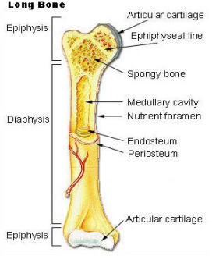
Using PowerPoint prepare slides for your discussion on the following:
- The FIVE TYPES of bones:
- Long Bones
- Short Bones
- Irregular Bones
- Flat Bones
- Sesamoid Bones
- Have a picture/diagram (of the bone & its structure/make up), purpose/job, examples of bones in this category & where these examples are found & why they are placed in this category.

Task 3
Using PowerPoint prepare slides for your discussion on the following: Find a blank picture of the skeleton & then identify the following 21 bones on it to include;
Cranium, clavicle, ribs, sternum, humerus, radius, ulna, scapula, ilium, pubis, ischium, carpals, metacarpals, phalanges x2, femur, patella, tibia, fibula, tarsals, metatarsals

Task
Using PowerPoint prepare slides for your discussion on the following:
Find a blank picture of the Vertebral Column & then identify each of the following regions: cervical, thoracic, and lumbar vertebrae, sacrum, coccyx
For each region you will need to identify & know:
- how many bones make up that region
- the function of the region
- identify where the Atlas & Axis Bones are in the vertebral column and their function

Task
Using PowerPoint prepare slides for your discussion on the following:
Prepare a slide on each of the FUNCTIONS OF THE SKELETAL SYSTEM which covers the following:
- what it is
- how the skeleton provides it
- why the function is important/useful
THE FUNCTIONS: support; protection; attachment for skeletal muscle; source of blood cell production; store of minerals

